**RESUME**

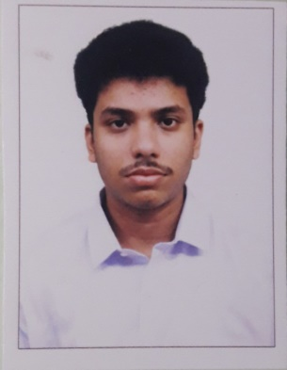

**Name :** Rohit Moitra

**Contact Number :**+91 8617298449 **|** +91 8902703270

**Email** **:** rohitmoitra3021@gmail.com

**Career Objective:**

Being a fast learner, I would like to learn and earn in order to meet the common objectives of the organization as a whole by utilizing a positive approach in everything that I do.

**Academic Qualification:**

|  |  |  |  |  |  |  |  |  |
| --- | --- | --- | --- | --- | --- | --- | --- | --- |
| **SEM** | **1** | **2** | **3** | **4** | **5** | **6** | **7** | **8** |
| **SGPA** | 8.33 | 8.45 | 8.73 | 8.65 | 8.57 | 8.07 | 7.76 |  |
| **Average** | 8.36(Till 7th Sem) | | | | | | | |

**Secondary & Higher Secondary :**

|  |  |  |  |  |  |
| --- | --- | --- | --- | --- | --- |
| **Examination** | **Board** | **Year of Passing** | **Marks** | | |
| **Obtained** | **Out of (Total)** | **%** |
| **12th Std** | WBCHSE | 2015 | 422 | 500 | 87.3 |
| **10th Std** | WBBSE | 2013 | 611 | 700 | 84.4 |

**Projects & Internships:**

|  |  |  |  |
| --- | --- | --- | --- |
| **SL. NO.** | **Company** | **Project Title** | **Duration** |
|
| **1** | CESC | Vocational Training | 2 Weeks |
| **2** | Mukesh-Hyundai | Vocational Training | 1 Month |

**Achievement (Academic)**

* Topper(2%)+Elite in Problem Solving through Programming in C(12 week course), certified by IIT Kharagpur, conducted by National Program on Technology Enhanced Learning (NPTEL).

**Interests & Extra-Curricular :**

Reading story books, Playing Cricket, etc..

**Language Known :-**

English,Bengali and Hindi.

**Personal Details:**

|  |  |
| --- | --- |
| Permanent Address | 23, Park Avenue, Modern Park, Santoshpur (Jadavpur), Kolkata- 700075 |
| Date of Birth | 19-07-1997 |
| Passport No | N.A |
| ADHAR Card | 828718149297 |
| PAN Number | EIDPM9989R |

**Declaration:**

I hereby declare that the information given above is true and correct.

**DATE: SIGNATURE:** 